**Teleconference with noise (interference) cancellation**

1. Background

In modern time travelling less and doing our meetings over telephone is a good way to reduce the pressure on our environment. Any disturbing noise can create annoyance in such a situation because the noise at one node in a multi-node conference may jam the reception at all the other nodes of the teleconference. In order to eradicate these interferences the system illustrated in Figure 1 below is proposed, where the teleconference attendants at the right end in Figure 1 knows that a nearby room is being renovated and therefore, and a smart-phone which is set in "pick up noise" mode is placed accordingly. When the phone conference starts, the leftmost smartphone in Figure 1 will receive two streams of sound: one containing a mix of the desired speech and noise from the renovated room and the other containing the noise-only stream. Our goal is to appropriately apply noise cancellation on the two streams in such a way which enables the system to extract only the voice signal removing as much noise as possible for a great teleconference experience.

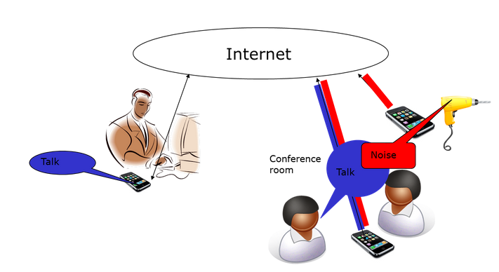

Fig. 1: Illustration of teleconference with noise (interference) cancellation.

1. PROBLEM FORMULATION AND SOLUTION

To cancel the noise and the echo generated in the user's environment during a teleconference (Figure 1) the theoretical knowledge learned in previous courses, mainly the contents of the course Adaptive Signal Processing (EQ2400) is widely used. To solve the problem using Adaptive Signal Processing techniques, the test of the algorithms will be done by MATLAB and the implementation in real time will be coded with Android in the Eclipse environment. As there are 5 members in the team and different areas where to work, everyone has been allocated in these different areas with certain responsibilities.

In order to work and complete the project, the team has been provided 5 cellphones to work with. We have distributed the uses of the phones as follows:

* Two phones for the users (One phone per user)
* One phone as a server
* One phone to record the noise
* One phone as a backup phone

With the information of the recorded noise, adaptive filtering techniques such as LMS will be used as noise cancellation tool and for echo cancellation, the first approach will be LMS as well. Anyway, there are different possibilities to analyze before starting the MATLAB program because the model can be slightly modified as per requirement.

The primary idea is to do the noise cancellation part first and then move on to echo cancellation part. The cancellation should be done in the server or in the receiver. Even though the cancellation tasks at the receiver seems to be more reasonable compared to doing it on the server, but all the possibilities will be taken into account to find the more-efficient approach.

Finally the model that will be used to treat the noise is shown in the Figure 2. On the other hand, the echo cancellation will follow a similar model but the CIOs need to study deeper the final model.

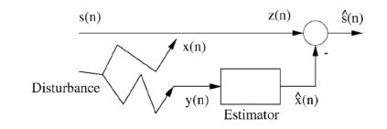

Fig. 2: Noise Cancellation Model

1. CONCLUSIONS
2. REFERENCES